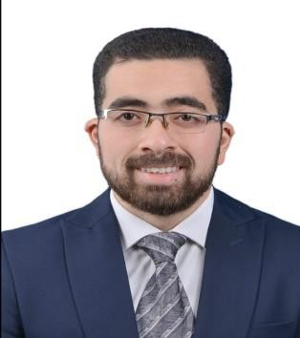

**Name: Mohamed Ahmed Abd Elaziz**

**Email:** [**mohamedalziz4@gmail.com**](mailto:mohamedalziz4@gmail.com) **Mobile: 01063234019**

**Linkedin:** [**mohamedelaziz9@gmail.com**](mailto:mohamedelaziz9@gmail.com)

**CAREER OBJECTIVES**:

Seeking a career opportunity in the field of pharmacy,

that offers a promising career path, in a healthy and productive environment, that encourages innovation and work through an interpersonal work style and teamwork.

# PERSONAL DATA

Name: Mohamed Ahmed Abd Elaziz Date of birth: 15/03/2000

Marital status: single

Military Status: Final dismissal Nationality: Egyptian

Driver license

# EDUCATION:

Year: 2018 High School: Experimental languages

Year: 2023 University : Faculty of Pharmacy , Delta University.

# JOB EXPERIENCES

- Pharmacy Name: Maher Pharmacies - Pharmacy Name: Noman Pharmacies

- from 1/8/2023 to 31/5/2024 - from 1/6/2024 to until now

- Position: Sinblaween - Position: Mansoura

# LANGUAGE AND COMPUTER SKILLS

Languages: Arabic (mother tongue)

English (Good)

Computer: ICDL

# INTERNSHIPS, TRAININGS AND ACTIVITIES

Pharmacy Name: Maher pharmacy

2021 - 2022

Position: Sinblaween

# CERTIFICATIONS

Bachelor of Pharmacy Pharmacovigilnce course Eva career course

Pharmajobia / delta university

# HOBBIES

Playing Football, Traveling.